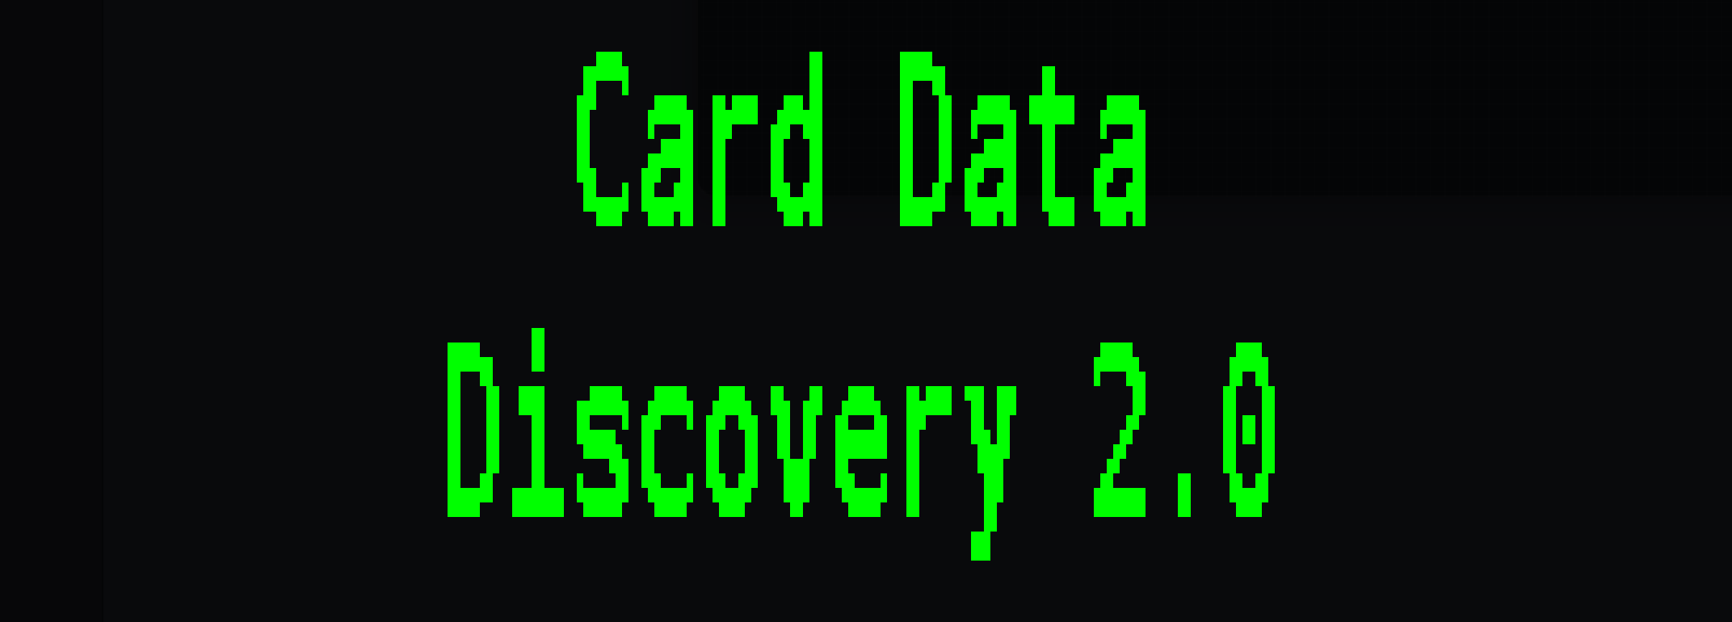

**Developed By,**

--- Md Mahfuzur Rahman, CVA

--- Engineer @ EIC

--- mahfuzur@eic.com.bd

--- [mahfuz33r.github.io](https://mahfuz33r.github.io/)

Table of Contents

1. Introduction 3

2. Installation and Setup 3

3. Usage Guide 4

4. Security Measures 4

5. Code Breakdown 5

6. Troubleshooting and Support 7

Card Data Discovery Tool Documentation

# 1. Introduction

The Card Data Discovery Tool is a secure and efficient solution designed to scan banking devices and identify any stored card information, such as Visa, MasterCard, Discover and AMEX numbers. This tool supports clients by ensuring compliance with data handling policies and assisting in identifying sensitive data that may require attention, removal, or encryption.  
  
This documentation provides a detailed breakdown of the tool's functionality, usage, and security measures, ensuring that both developers and end-users have a comprehensive understanding of how the tool operates.

# 2. Installation and Setup

The Card Data Discovery Tool is packaged as an executable (exe) file for ease of use. This means that clients can directly run the file without needing to install any additional software.  
  
To install and set up the tool, please follow these steps:

1. **Ensure Requirements are Met** :  
 - Operating System : The tool is compatible with Windows OS.  
 - Permissions : Run the exe file with administrative privileges to allow full access to scan drives.  
  
2. **Running the Tool** :  
 - Simply double-click on the provided exe file to launch the Card Data Discovery Tool. The tool will automatically detect connected drives and initiate the scanning process.  
 - A command-line interface will guide users through the scanning process.

# 3. Usage Guide

This tool is straightforward to use. After launching the exe file, it will automatically begin scanning all connected drives for potential card data based on predefined patterns. The results and progress will be displayed on the screen and also logged in a separate log file for detailed review.  
  
The scanning process involves the following steps:

1. Drive Detection : The tool will list all available drives on the device.  
2. File Scanning : Only files with specific extensions (like .txt, .docx, .xlsx) are scanned for card data patterns.  
3. Pattern Matching : The tool uses predefined card number patterns to identify potential card data in files.  
4. Logging : All operations are logged for tracking purposes, with minimal information to protect user privacy.

After successfully complete the scan,

It will create a log file details of logging information when running the tool. A file name “card_data_discovery_output.txt” where details card number and location of each file will be found. Another two file is valid_card_data.txt & invalid_card_data.txt will be found where you found true positive and false positive result.

# 4. Security Measures

The Card Data Discovery Tool is designed with security as a priority to ensure client confidence:

1. **Read-Only Scanning**: The tool operates in a read-only mode on files, ensuring no data is modified during the scanning process.

**2. File Filtering**: Limits scanned files by extension to reduce unnecessary processing and potential exposure to malicious files.

3. **Minimal Logging**: Only essential operational data is logged, such as timestamps and process statuses. Sensitive data found during the scan is not stored or retained in logs. Logs all processed files, ensuring transparency and traceability.

4**. Limited Regex Patterns**: Uses regex to recognize card numbers, and only known card types are scanned. Uses non-intrusive regular expressions to match common card formats (Visa, MasterCard, AMEX, Discover) without storing card numbers beyond the scanning process.

**5. Restricted Email Login**: Validates user email against a set of known credentials to restrict access to the tool.  
6. **Data Privacy**: The tool runs under the current user permissions, and sensitive areas require elevated access.

7**. Luhn Algorithm Validation**: Ensures that detected card data is valid, preventing false positives.

# 5. Code Breakdown

This section provides a high-level overview of the main functions used in the tool for those interested in the technical aspects of its operation.

**get_drives**

* **Purpose**: Detects available drives on the system for scanning.
* **Returns**: A list of drive paths.
* **Security Note**: This function uses psutil library to access drive information, ensuring comprehensive scanning.

**get_file_extension**

* **Purpose**: Extracts the file extension from a file name to determine if it should be scanned.
* **Input**: file_name (str) – name of the file.
* **Output**: The file extension as a lowercase string.
* **Usage**: Helps in determining if a file’s type is permitted for scanning, based on the allowed_extensions.

**Icon**

* **Purpose**: Displays a stylized banner using pyfiglet.
* **Output**: Prints a centered banner on the console.
* **Note**: Adds a branded visual element to the tool.

**is_valid_email**

* **Purpose**: Validates that an email address belongs to the required domain.
* **Input**: email (str) – email address to validate.
* **Returns**: True if the email format and domain are correct; otherwise, False.

**luhn_check**

* **Purpose**: Validates card numbers using the Luhn algorithm.
* **Input**: card_number (str) – card number to validate.
* **Returns**: True if the card number is valid according to Luhn’s algorithm; otherwise, False.
* **Security Note**: Ensures that detected card data is actually valid.

**valid_card_data**

* **Purpose**: Extracts and validates card data from a specified file, categorizing them into valid and invalid files.
* **Input**: file_path (str) – path to the file to scan.
* **Output**: Saves valid and invalid card data to output2_file and output3_file respectively.

**search_card_data**

* **Purpose**: Searches files for card data patterns and validates against supported types.
* **Input**: file_path (str) – path of the file.
* **Output**: Returns any found card data and logs files that could not be read.

These patterns allow the tool to detect specific card formats while maintaining system performance.

# 6. Troubleshooting and Support

If any issues arise, refer to the log file `card_data_discovery.log` for details on any encountered errors. Below are some common issues and solutions:

1. Permission Errors : Ensure the tool is run with administrative privileges if access to all system drives is required.

2. Missing Dependencies : Ensure all dependencies are included in the exe. If not, contact the developer or re-run the exe build process.  
  
For any additional support, please contact our technical support team or refer to the developer documentation. [mahfuzur@eic.com.bd]